The Title Line are Centered, Linespace Exactly at 17-point, Capitalized First Letter of Each Word and the Font is Times New Roman 16-point
Subtitles Use 13-point type for the subtitle, aligned to the center, linespace exactly at 15-point with bold and italic font style
First Author (Surename Name)¹, Second Author² and Third Author³
¹Sample University, Address, ZIP code, City, Country
²Other institution……………….
Email:……………

Abstract
The abstract of the full paper summarizes the content of the chapter in 150 to 250 words. Don’t include reference citations or undefined abbreviations in the abstract, since abstracts are often read independently of the actual chapter and without access to the reference list. It should be set in 10-point font size, justified. There should be a space before of 12-point and after of 3-point.
Keywords : A maximum of 5 keywords is allowed for each contribution.

Introduction
Manuscript consist of 8 to 10 pages, include of title, abstract, introduction, geoscience framework, methodology, discussion, conclusion, and references. Author names and the affiliations are also centered. The Author Name font is Times New Roman 11 and affiliation(s) is Times New Roman 10.
The first-level section titles are in Times New Roman 12 Bold and use capital letters only for the first letter of each word and in Times Roman 11. The first lines of paragraphs are indented 0.7 centimeter and no blank line is required between two paragraphs. The text is right-justified are shown here.
The paper size must be set to A4 (210x297 mm). The document margins must be the following:
- Top: 3.5 cm;
- Bottom: 3.0 cm;
- Left: 2.0 cm;
- Right: 2.0 cm.
It is advisable to keep all the given values.
Regarding the page layout, authors should set the Section Start to Continuous with the vertical alignment to the top and the following header and footer:
- Header: 1.4 cm;
- Footer: 1.7cm.
Any text or material outside the aforementioned margins will not be printed.

Method
The method section should be presented in one paragraph without subsections and should briefly cover: the type of research, the type of data, the procedure for data collection, the techniques used for data analysis, and how conclusions are drawn. If the paper is a literature review or conceptual work, the research method does not need to be included. (Written in Times New Roman 11).

Result and Discussion
The results and discussion can be presented in subsections. Clearly discuss the main topics in line with the research problems, objectives, and the theories used.
There is no blank line between sections and continue as shown. Tables and Figures can be made either as two columns or one. Their captions use the Times Roman 9. Table heading is printed in Times New Roman 8-point italic and centered.

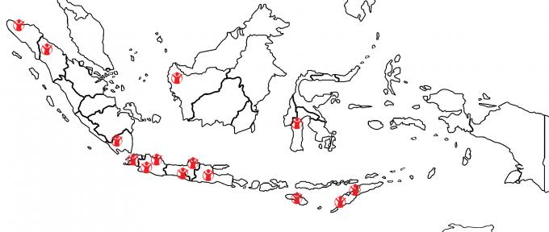
Figure 1. Caption uses Times Roman 9 and centered

Subsection Example
The Second level headings are in Arial 12-point Italic as shown above. There is no blank line separating the subsection heading from the preceding paragraph. Avoid the use of Third-level headings.
The style of References is as follows: in the text body please use the name of author and the publishing date (Somebody et al., 1990). The style of the list of references is shown below.

Table 1. This Caption has one line so it is centerd
 | Column Heading 1 Column Heading 2
Row Heading 1  Row Heading 2  Row Heading 4 | All information in a table  is printed using  Times Roman 8  etc.

Conclusion
In conclusion, the findings of this study confirm that [briefly state the main findings], thus addressing the research question of [insert research question] and achieving the objectives set forth. This relationship highlights [summarize the connection between research question, objectives, results, and discussion].

Acknowledgments
We would like to express our gratitude to the funding agency for their financial support, and to those who contributed to this research outside of the authors.
Please send us the electronic copy of your paper in “word format”. We appreciate it very much on your effort to make sure that the submitted paper is print-out ready using the format that we provide. We are waiting for your full paper not later than November 9, 2024

References
A minimum of 25 references is required, with 80% sourced from academic journals and 20% from books. The references should be formatted according to the APA 7th Edition style (American Psychological Association 7th Edition).
Seventy percent of the references used must be recent publications, published within the last 5 years.
Ferrer-Estévez, M., & Chalmeta, R. (2021). Integrating sustainable development goals in educational institutions. The International Journal of Management Education, 19(2), 100494.
Leite, S. (2022). Using the SDGs for global citizenship education: Definitions, challenges, and opportunities. Globalisation, Societies and Education, 20(3), 401-413.
Arini, D., & Nursa’ban, M. (2024). Contribution of Artificial Intelligence (AI) in Education to Support the Achievement of Sustainable Development Goals (SDGs) 2030. Jurnal Penelitian Pendidikan IPA, 10(SpecialIssue), 39-45.

